PRACTICAL NO. 05
5. Configuring a Zone-Based Policy Firewall
Topology :
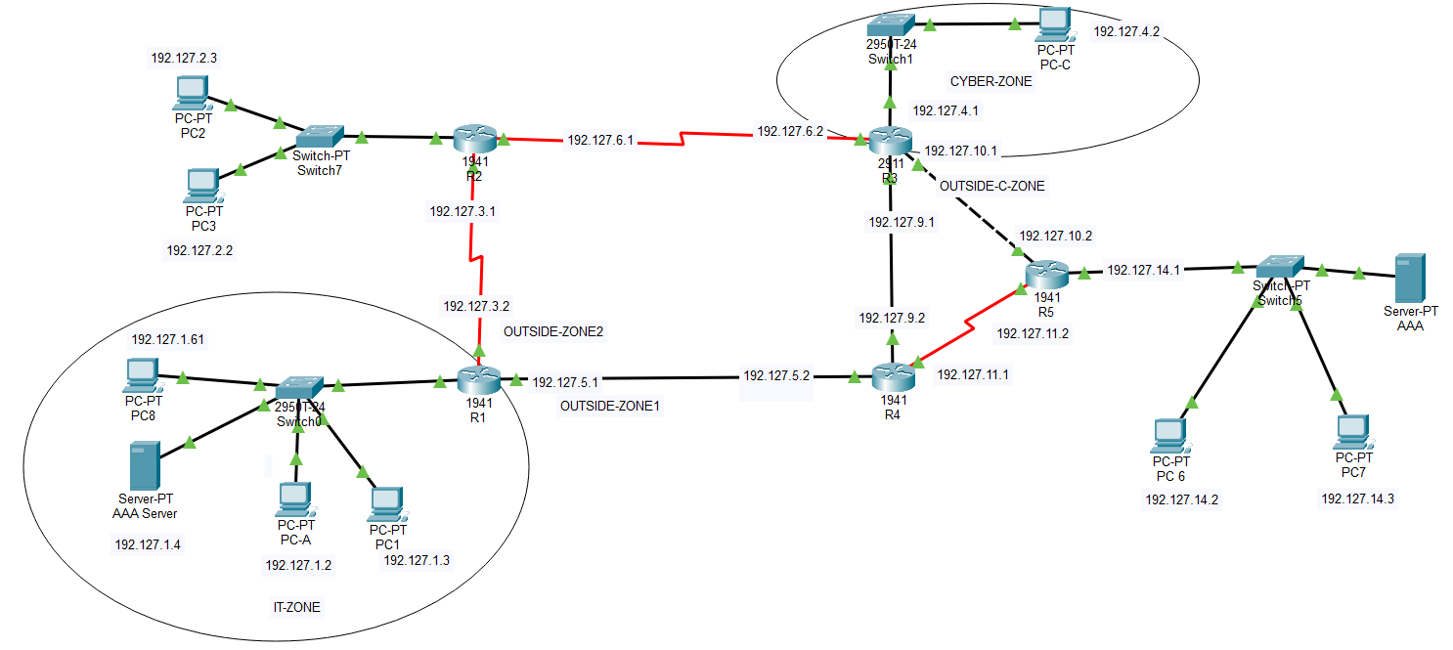

- IT-ZONE
Applying ACL to router(R1) and also defining zones
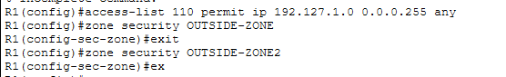
Create a class map referencing the internal traffic ACL
Specify Firewall Policies
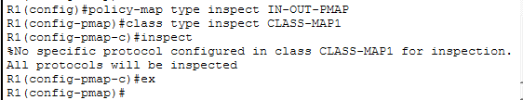
Apply Firewall Policies
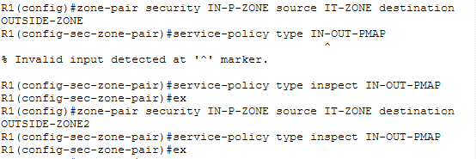
Assigning zones to the router’s interfaces
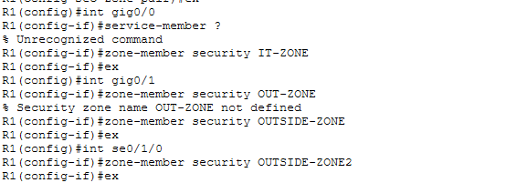

Accessing from PC-A to Server AAA i.e considered as a PC-C
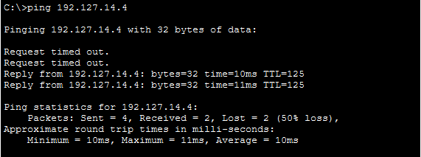
Access Server-c from PC-A via browser repeat also for PC-B.
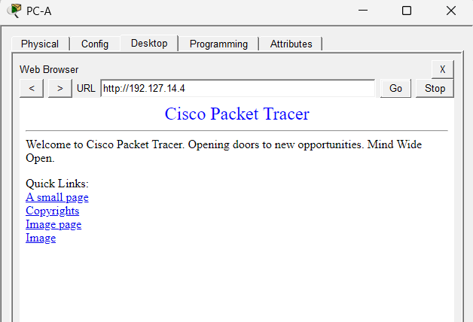

Accessing from PC-A to SSH of R4 .
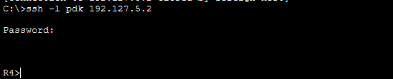

To view establishes sessions
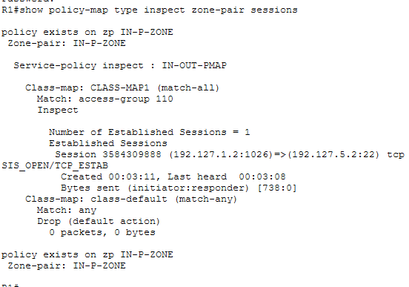
From Server-AAA (PC-C) to PC-A getting fail which is actual behaviour we want
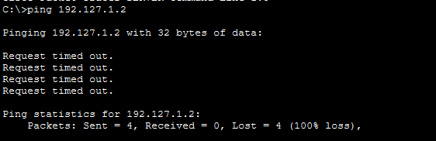

From R4 to PC-A getting fail which is actual behaviour we want
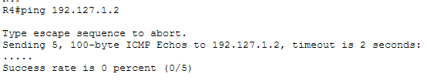

- CYBER-ZONE
Applying ACL to router(R3) and also defining zones ()
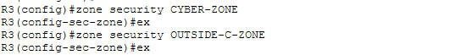
Create a class map referencing the internal traffic ACL (CYBER-ZONE)
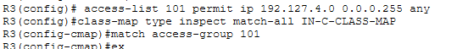
Specify Firewall Policies(CYBER-ZONE)
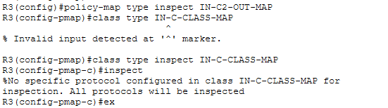
Apply Firewall Policies(CYBER-ZONE)
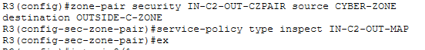
Assigning zones to the router’s interfaces(CYBER-ZONE)
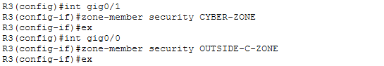

Accessing from PC-B to Server AAA i.e considered as a PC-C (CYBER-ZONE)
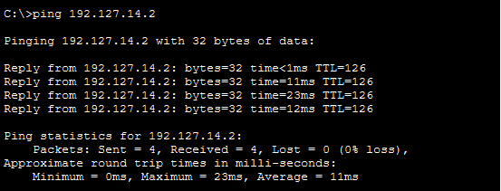

Accessing from PC-B to SSH of R5 .
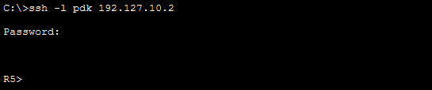
To view establishes sessions
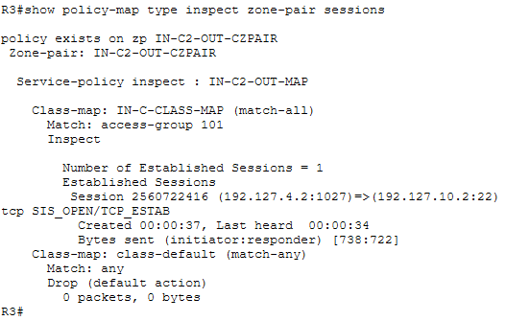

Access Server-c from PC-B via browser .
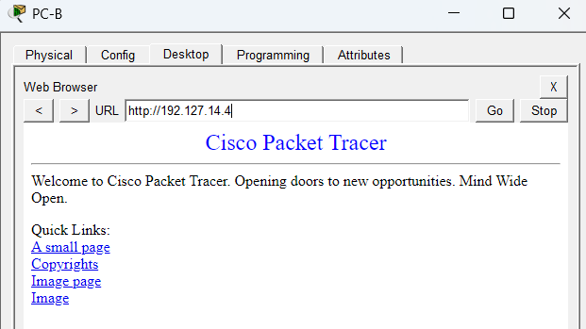

From Server-AAA (PC-C) to PC-A getting fail which is actual behaviour we want
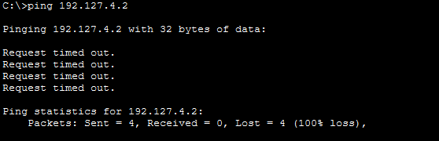

From R4 to PC-A getting fail which is actual behaviour we want
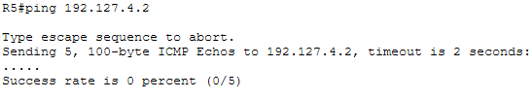

Allow IT-ZONE to access CYBER-ZONE
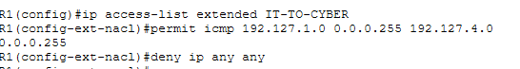
Allow CYBER-ZONE to access IT-ZONE
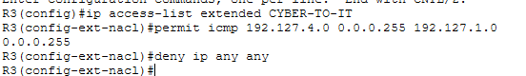
Block OUTSIDE zones from accessing IT-ZONE
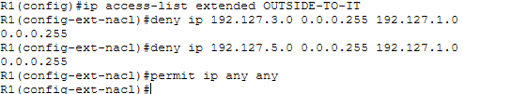
Create class map
Create Policy Maps

Create Zone Pairs R1

